Trajectory Generation

How to generate driveable trajectoreis.
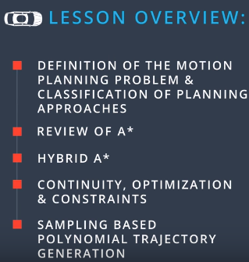

Defining the Motion Planning problem

We saw some path planning algorithms that solve the motion planning problem like Dynamic Programming, Optimal Policy, and A Star.

Configuration Space is a term used to define all possible configurations our robot in the given world.

Given 3 things:
- the starting configuration (From the Localization and sensor modules)
- the goal configuration (from behaviour layer)
- Constraints describing how the vehicle is alowed to move, dynamics, and description of the environment. (pysics, map, traffic)

Prediction module gives us information about how the obstical region will evolve in time. This way, the sequence of actions we generate takes into account other vehicles and pedestrians.

Problem:
A squence of feasible movements in the configuration space that move the robot from a start configuration to an end configuration without hitting any obsticals.

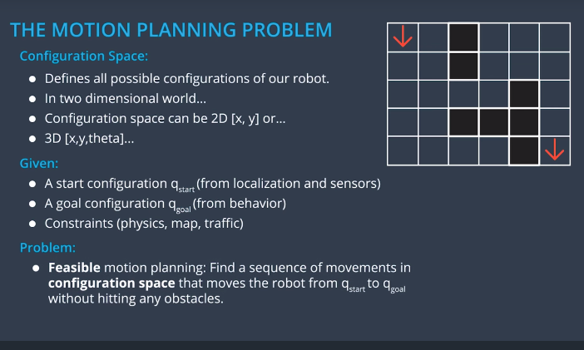

Properties of Motion Planning Algorithms

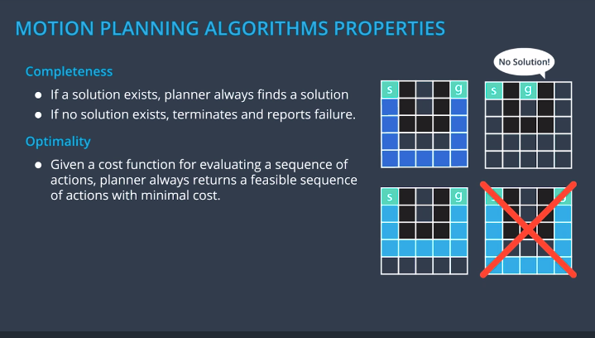
Completeness and Optimailty are two important Properties of a Motion Planning algorithm.

Types of Motion Planning Algorithms

There are many classes of Motion Planning algorithms.

Combinatorial Methods:
- Focus on dividing the free space into small pieces, and then solving the motion planning problem by connecting these elements back together
- Very intuitive ways to find the intial approximate solution, but they usually dont scale well for large environments.
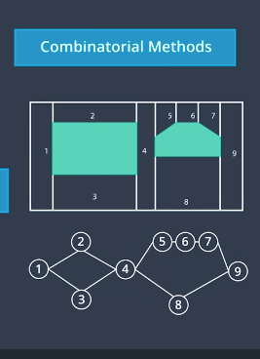

Potential Field Methods
- reactive methods
- each object has somewhat of a anti gravitational field, which makes it harder for the vehicle to come close to it. This encurages the trajectories we generate to stay away from objects in the environment.
- main problem is that it can push us into local minima, which can result in not finding the correct solution

Optimal Control
- consists of trying to solve the motion planning problem and the control input generation in one algorithm.
- using a dynamic model for a vehicle, a start configuration and an end configuration, we want to generate a sequence of inputs (steering inputs and throttle inputs), that lead us from the start to the end configuration while optimizing a cost function relative to the control inputs (Minimizing gas consumption) and relative to the configuration of car (staying a good distance from other vehicles)
- difficult to include all the constraints for other vehicles in a way that works well enough for the algorithms to work fast.

Sampling Based Methods

- Popular due to the somewhat easier to compute definition of the free space
- use a collision detection module that probes the free space to see if a configuration is in collision or not
- unlike combinatorial or optimal control methods, which analyze the whole environment, not all parts of the free space need to explored in order to find a solution

- Explored parts are stored in a graph structure that can be searched by a graph search algorithm like dijkstra or A*.

- 2 Main methods:
Discrete methods:
- rely on a finite set of configurations and inputs
Probabilistic methods:
- rely on a probabilistic sample of a continuous configuration space
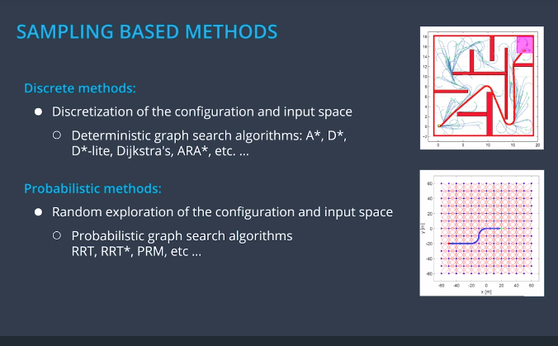
- the set of possible configurations, or states that will be explored is potentially infinite, which gives these algorithms the nice property of being probabilisticly complete and even sometimes probabilsitcily optimal (it will always find a solution given enough computation time)

A* Search Reminder

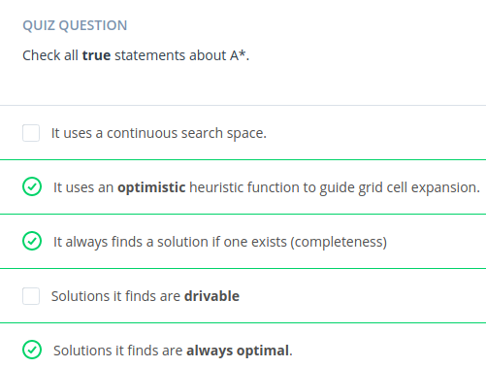

The answer of the solutions it finds are driveable or not is somewhat tricky.

It depends on the search space being used and what it represents. If the search space only represents the postion x, y, then there is no garuntee that the sequence of positions returned by A* are drivebale.
However , if the search space was more complex and included heading and restrict connections between cells so that when we close a cell, we add to the open set, only cells that the transition from the closing cell to the open ones is driveable. The resulting path will then be driveable.

A* solutions are always optimal with respect to the discritization of the environement used as an input.
The more granular the discritization, the better the solution. (This is called resolution optimal)

Hybrid A* Introduction

In real robotic path planning, the world is continuous and not discrete, and therefore adjustments need to be made to A* in order to implement it as the motion planning problems solution.

Hybrid A* is an example of an algorithm that works in continous environments, and also gives a driveable path.

The key to the solution using A* has to do with the state transition function.

Suppose you are in a gridcell, and you apply a sequence of infinitesimally small movements.

Instead of closing the current gridcell, and opening the new one, what hybrid A* does is memorize the exact co-ordinate of the robot in x’, y’, and theta’ and then associate it with the grid cell the first time the cell is expanded.
It then uses that specific location as the starting point when expanding, to figure out what the next cell might be.

It may happen that you go explore a previous grid cell, which can have a different combination of x’, y’, and theta’, but because in A*, the cells explored tend to be along the shortest path, some of those state are cut off and never considered again.

This leads to a lack of Hybrid A*’s completeness, so there might be solutions to the navigation problem that this algorithm doesnt capture, but it does give us correctness. So as long as the motion equations are correct, the resulting paths can be executed.
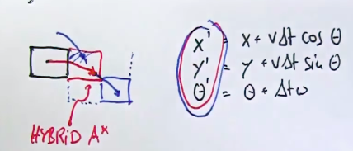

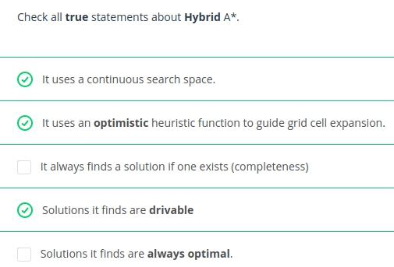

The completeness is sacrificed, because we only allow one continous configuration per discrete cell.

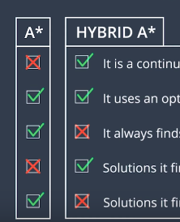

Hybrid A* in Practice

The update equations for a robot using Hybrid A* was shown earlier as the general case, but here is the general one.
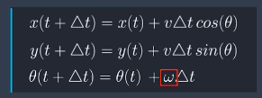

The key difference is omega, which is hte heading rate of change.

For some robots, we can specify an entirely different omega in entirely different states, but that would mean that the robot can turn around its z-axis without constraints.

This is not realistic for a car though, so we should rely on the bicycle model to determine the heading rate of change.

L is the length between the front and back tires, delta is the steering angle, and v is a constant positive velocity.

For Hybrid A* we need to decide which configuration can be reached from the current node, in order to add them to the open set.

In practice we would use a number of steering angles from the maximum left turn to the maximum right turn, but the more angles we consider, the longer the algorithm would take to complete.

For praciticality, we will choose 3 angles, the max left, 0, and the max right.

If a cars maximum steering angle is 35 degrees, we will consider -35 degrees, 0 degrees, and 35 degrees.

This way we can expand our search tree with 3 new motion primaticves, go left, go straight, and go right.

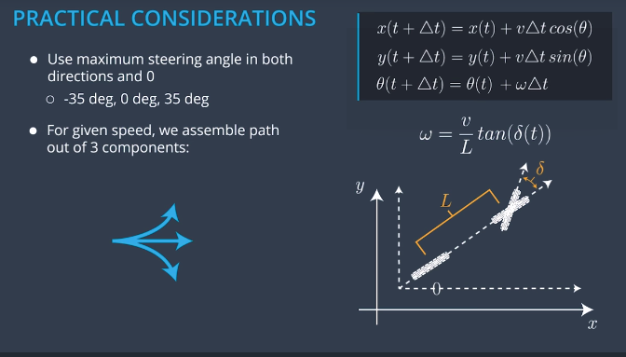
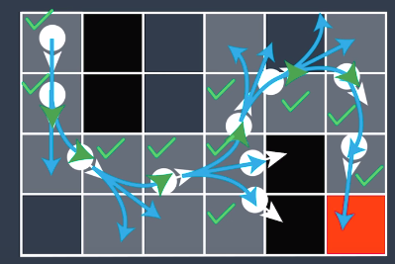
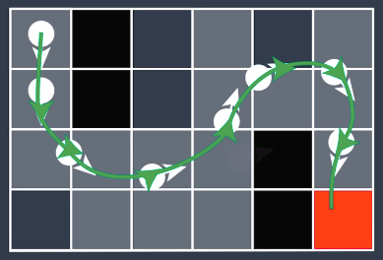

The solution we end up with is a continous path to the goal, but it might not be the smoothest solution. How do we get the solution to look as smooth as one a human would make, and what would happen if hybrid A* did’t find a solution even though one exists.

In order to make finding the solution more likely, we could increase the resolution of our grid, or adding a heading as a dimension in our search space.

From Juniour- Standfords entry in the urban challenge.

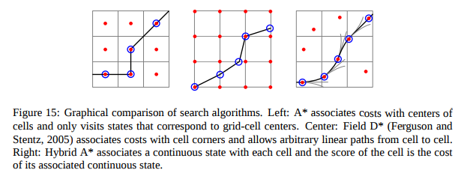
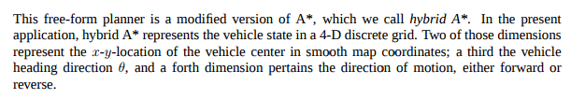
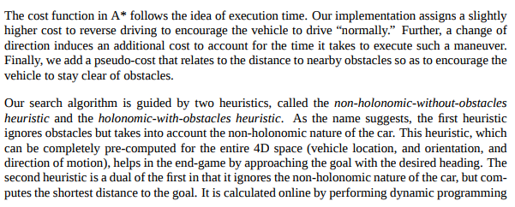
If we have two individually admissible heuristic functions h1 and h2, which of the following combinations are also valid.

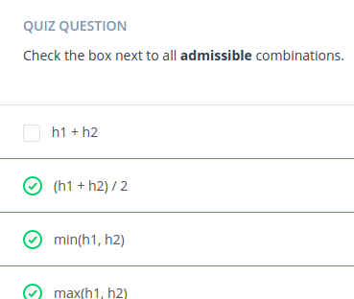

Hybrid A* is one of the best algorithms for finding trajectories in unstructured environments.

Environment Classification

Unstructured

An example of an unstructred enviornment are ones that are parking lots, and others similar to a maze.

These environments tend to have less rigid rules than highways or streets, and also have lower driving speeds.

They also dont have obvious reference paths that correspond to where we should be driving 90% of the time due to refrence paths changing so frequently.

Structured

An exmaple is Highways or street driving.

Constrained by rules on how we can move. Things like direction of traffic, lane boundries, and speed limits. They are great for guidence as to what our trajectories should look like.

The road structure itself can be used as a reference path.
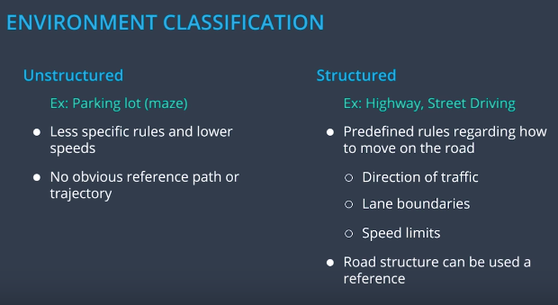
A* isnt used in structured environments due to the fact that it doesnt take advantage of all this information.

Frenet Co-ordinates reminder.

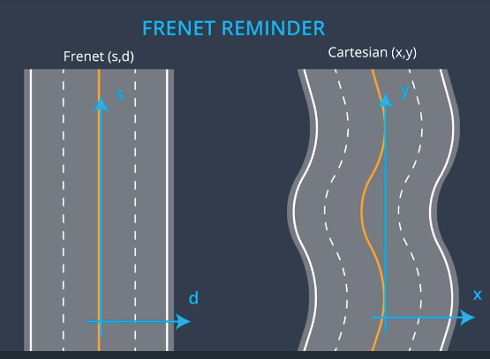

Although we can take the center of a lane as a reference line, calculated a refrence trajectory with A* and smoothing the path would mean that we could have reference line that we know the vehicle should always follow if possible. If the corresponding portion of a line is empty, the center of a lane as a refrence line isnt good.

The Need for Time

It is important to emphasize that we should not only compute a sequence of configurations, but also decide when we are going to be in each configuration.

Having our configurations at consecutive timesteps clump togehter is evidence that our vehicle is to slow down at this part of the trajectory. Without each configuration having an associated timestep, we would not have any sense of when we should be there.

Without time, there is no full story that can be conveyed by a trajectory.

In static mazes, it is fine to ignore time, but in a dynamic environment, we need to consider time in order to avoid collisions.

The incorporation of time means that driving in traffic is a 3 dimensional problem. You would have the same with x and y coordinates. Frenet coordinates make it easier, but it does not change the nature of the problem, which is planning a trajectory in a dynamic environment.

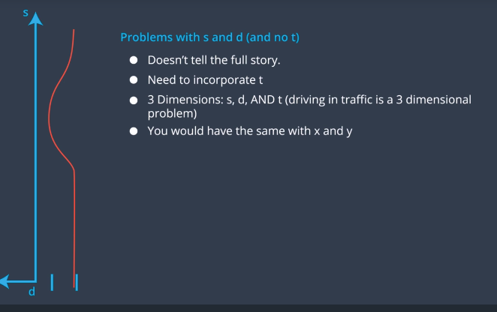

So now that we know we need to incorporate time, our algorithms to solve the path planning problem were A* and Hybrid A*, but none of them considered time. How do we map our configuration points to a value in time.

In path planning we imagin we imagine taking our driving surface, and laying some discritized grid on it. Then we specify a start state and a goal state.

Those are what are the outcomes of algorithms A* and Hybrid A*, however neither of them consider our predictions. How do we incorporte the predictions of locations of other vehicles into our path.

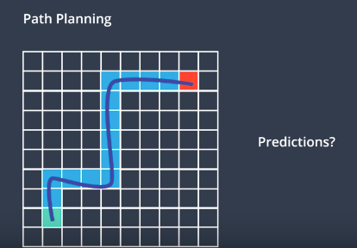

One way to visualize time as a 3rd dimension to the trajectory planning problem is to imagine looking at the road from some angle and time would be the dimension going up.

Having a path is not enough when there are dynamic objects around us, which is all the time in autonomous driving.

We have to not only plan a sequnece of configurations s, d, and theta, but also how they are set up in time.

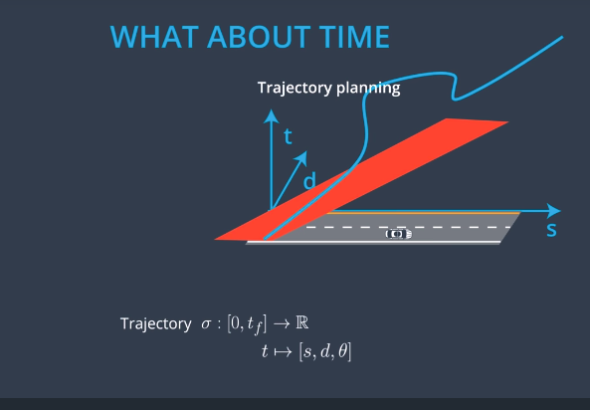

By definition a trajectory by definition is a function where for any time t, there is an associated configuration for the vehicle.

How we generate this trajectory is by seperating the planning we do in the s dimension, from the planning we do in the d dimension.

Instead of making decisions based on one picture in 3 dimensions, we make decisions based on 2 pictures of 2 dimensions each.

Example:

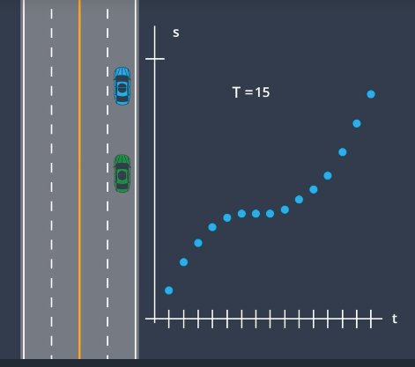

In this case beacause we look at the trajectory in terms of s vs t, we can see that the green vehicle has stopped behind the blue vehilce. This is seen in the flat slope of the graph.

This detail is not obvious in the 3 diminsional graph of s vs d vs t.

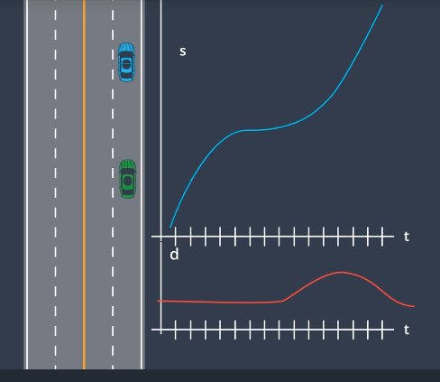

Looking at both trajectories simultaneously will telll us the entire motion of the car over time. It isnow not just a path but a full trajectory.

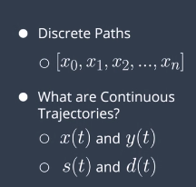

Things to consider.

A method for trajectory planning in structured environments (Like highway driving)

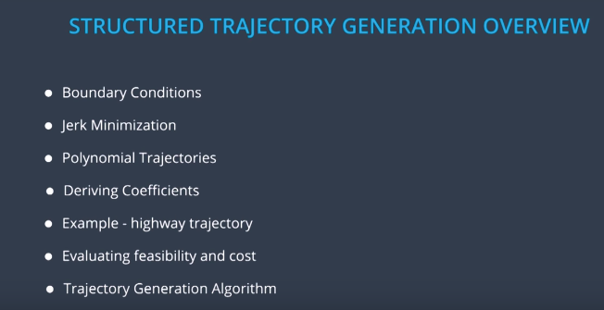

Jerk minimization generates a nice smooth trajectory from a start configuration to an end configuration.
We will use a polynomial to describe our trajectory, and how we can derive the coefficeints of the polyhomial that will take us from our start to our goal.

We can then use a Trajectory Generation Algorithm to generate many jerk minimizing trajectories, compare them by evaluating their feasibility and cost, and then choosing the best one as the trajectory we should follow.

Trajecotries with Boundary Conditions

We want to generate continous trajectories.

We describe our current position as the origin of our s vs t and d vs t graphs for effiency.

When we plot our points for a goal position, we can use it to set boundaries on the area our trajectory should exist.

Afterwards, we need a smooth trajectory that has no dicontinuities velocities in order for it to be feasible.

How much continuity and smoothness is required for our trajectory to be feasible by our controller?

What paremetr is used to determine Humans feeling of discomfort?

It isnt velocity, or even acceleration. Accelerations are perfectly comfortable up to 1G, which cars do not pass.

Jerk is what we need to minimize.
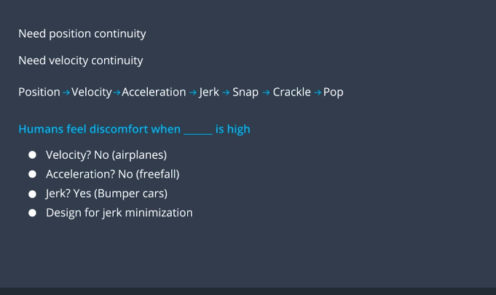

Jerk Minimizing Trajectories

It is relatively easy to compute in one dimension.

We want to find the total jerk squared in order to penalize both positive and negative jerk.

We want a function S(t) that minimizes the total squared Jerk.

If we go through the math we require to find the minimial trajectory, we find that:

A Key Fact is that derivatives of order 6 or more have to be 0 in order for s to be minimial.

Therefore we represent 1D jerk minimum trajectories as 5th order polynomials.
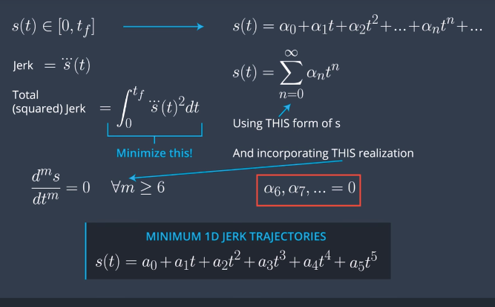

This means that there are 6 coefficients and 6 tunable parameters for finding Jerk Minimal Trajecotries and 6 Boundary Conditions. Our Boundary Conditions are based on our initial position, velocity, and accleration, as well as our final position, velocity and acceleration.

Now this is only for a 1D situtaion, but the same thing extends to d, meaning that our d value is constrained to initial positiion, speed and acceration, as well as final posiiton, speed, and acceleration.

That is gives us 12 variables in total to pick in order to fully define our motion for a vehicle in s and d over time.
The initial state gives us the longitudinal and lateral boundary conditions at time T = 0.
We get to pick the end boundary condititions.

For the next examble we wil look at a case where the intial and final accelerations are 0, which is reasonable for a lane change.
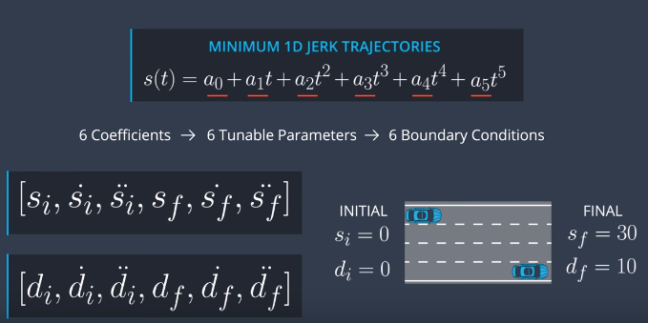

This examble would make our boundary conditions look like this:
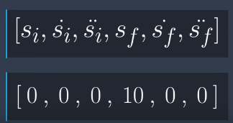

It is important to understand that even though we are trying to find Jerk Minimal trajectories for the current situtaiton given these boundaries and a time value to reach the goal, It is heavily dependant on these conditions.

If not enough time is given, and our boundary conditions are not close together, we will not have a good resulting trajectory.

Now, how do we find the coeffiecients that satisfy these boundary conditions?

Derivation
http://www.shadmehrlab.org/book/minimum_jerk/minimumjerk.htm

We saw earlier that the position of a Jerk Minimal Trajectory is defined by a quintic polynomial.

How do we find its 6 coeffiencets that safisfy the boundary conditions?

Step:
1) Derive your position equation twice to get an equation for velocity and for acceleration
2) We can then use our 6 boundary conditions to make 6 quations, but to simplify, we can sub in t = 0 for our initial boundary conditions, giving us 3 equations instead of 6.

With more simplifying, we can seperate our 3 equations into known values and unknown values and solve it like a system of equtations. The best wayy to solve it is to use matrix representation and using a software libary to compute the inverse of the matrix to solve.

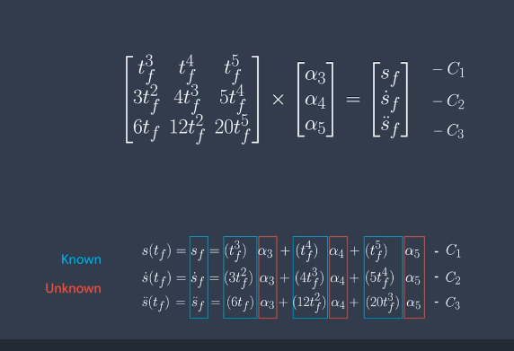

How our Polynomial Sovler should work is it takes your initial state, a final state, and a time T. With this information, twe output our 6 coefficients which uniquely define the polynomial that defines that trajectory.
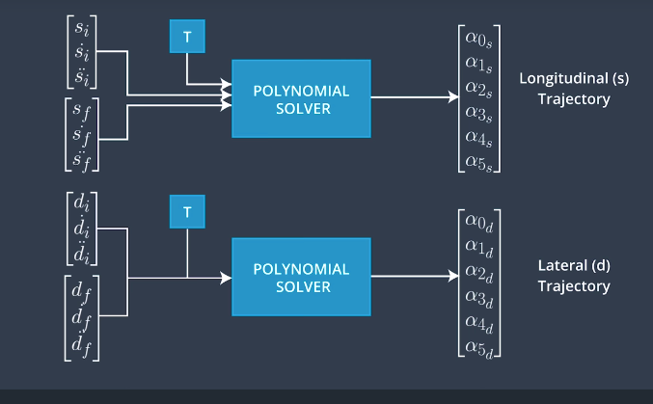
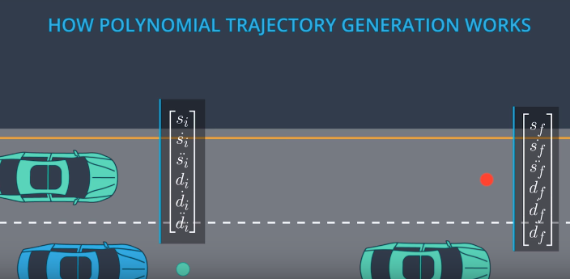

When Determining The Feasibility of a Trajectory, what should be Checked?
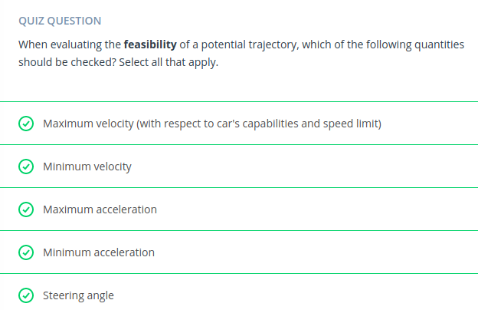
A car can only go so fast, but minimum velocity corresponds to going backwards, which we shouldnt do.
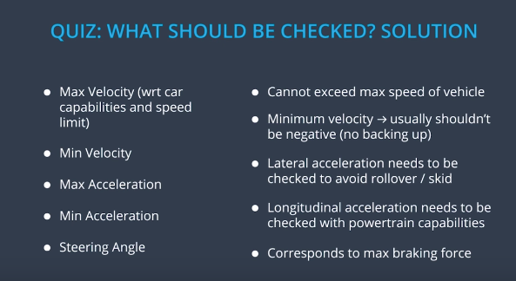

Implementing Feasiblility

How can we do some initial validation for our trajectory.

Some assumptions we will make is, neglecting the curvature of the road, and asssuming its locally straight.

We will also assume that our heading is aligned with the road, which means that s double dot is the Longitudinal acceleration of our car.

Then we could check that this acceleration is less the max acceleration our engine could apply, and more then the max breaking accleration of the car. Right now this could be a fixed value, but in real life this is computed using information about the friction of the road.

We can also check the lateral accleration values magnitude, so we can set it for a certain level of comfort.

For the steering angle, the bicycle model of a vehicle tells us that there is a relationship between the steering angle and the radius of the circle of curvature, where L is the distance between the wheel axis, and R is the circle radius. This lead us the an equation for the max curvature allowed at any point in the accleration.

Remeber that on a trajectory the curvature is given by the ratio of the difference in the heading angle and the position.

Then we can check the velocity by ensuring it meets the standards of the map like a speed limit, but also a minimial velocity is also very useful for highways where go slow or driving backwards is prohibited. This means that a negative s dot is not allowed.
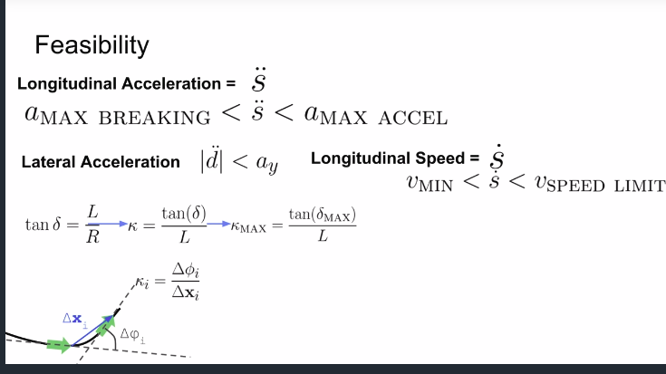

Putting it all Together

Now, we know that the behaviour layer of our self driving car is what is sending us our final configuration, but we know that sometimes it will not send us an exact end configuration to reach and just an approximate one.

We still need to determine what a good resulting velocity and acceleration is for our car, and most times, s and d values are not fixed.

We can then take a sampling based approach, where we sample configurations in the approximate area, and then generate trajectories to each configuration.
The best trajectory is the one that is followed.

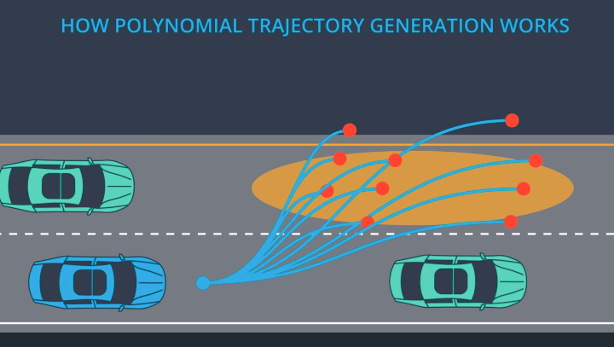
We get rid of trajectories by determining if they are drivable or not, and wheter those trajectories lead to collisions with the information recieved from the prediction layer.

Now with a set of trajectories that are collision free, and driveable, and jerk optimal in each dimension with respect to the start and goal configurations

We then rank each trajectories by defining a cost function.

How do we cost evaluate our trajectories?

Jerk:
Even though our trajectories are Jerk Optimal, some of our trajectories may have lower Jerk than others. We would also need to consider longitudinal vs lateral Jerk and what is worse for confort. Turns out side to side Jerk is more uncomfortable, and therefore should be priortized when minimizing the Jerk for our trajectory.

Distance to Obsticales:

We perfer being farther away from other vehicles.

Distance to the Center of the Line:

We can perfer to be closer to the center of the lane.

Time to Goal:

All things being equal, we would perefer to reach our goal earlier rather than later.

There are many things we can consider which trajectory to take, and the tricky part is how do we balance htem all?

Often our goals conflict, like the goal of minimizing lateral jerk may conflict with minimizng our distance to the center of the lane.

In practice most of the hard work is done in balancing these cost functions.
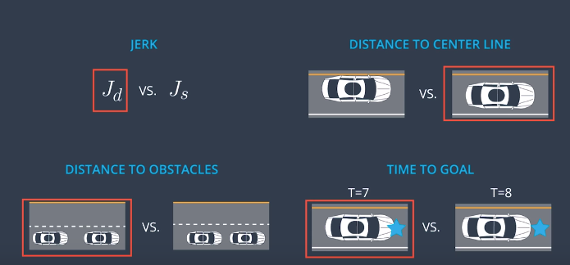
Now that we have some criteria for a cost function, lets compare the trajectories in the image above.

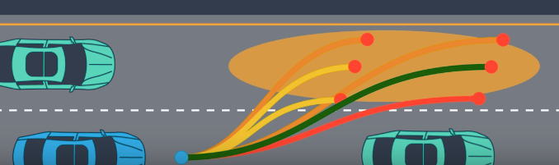

The costs associated with being close to other vehicles, minimizing Jerk, and wanting to be in the center of the lane all lead to a final optimal trajectory being selected.

Conclusion

No trajectory genration plan is the best for every situation, so in reality most self-driving cars have many trajectory planners they can use depending on the situtation.

They may use Hybrid A* in parking lots where it is not a structured environment, polynomial trajectory generation in low traffic highways, and maybe several others for situations like intersections, high traffic, etc.

